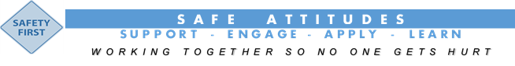

* Support
* E:Engage
* Apply
* Learn
* Provide your backing and commitment to working safely so no one gets hurt.

* Proactively participate in and enhance safe work practices to keep yourself, work colleagues and others safe.
* Employ your knowledge, positive attitude, training and education in doing things right first time and in a safe manner.
* Ensure that lessons are learnt from past performances and incident so we continually improve our safe work practices.